Final Project Write Up
Submission by Ananya Bhaktaram, Sonia Dhawan, Curtis Ehlert, and Jacqueline Ferri.
Introduction and Objectives
Unidentified flying objects (UFOs), also known as unidentified anomalous phenomena (UAP), are consistently sighted and reported across the United States. The United States has the largest concentration of reported UFO sighting of any country in the world (NUFORC, 2021). UFOs are understood to be mysterious objects whose status is unknown, and in pop culture are heavily associated with alien (extra-terrestrial) activity, among other conspiracy and supernatural affiliations. There has been growing public interest and belief in the existence of UFOs (Saad, L., 2021). Nearly half of all U.S. voters believe that the U.S. government is keeping the existence of UFO’s a secret (Menezes, D., 2025). As a result, rigorous study exploring correlative relationships between UFO sightings and other factors, such as health, climate, and the tendency to report separate but distinct supernatural phenomena, is lacking.
There is one paper, published in 2023, that analyzes temporal associations between UFO sightings and Emergency Room (ER) visits across the United States to determine if sightings have any relationship to population health (Worsham et al, 2023). Their results found no meaningful association. They also suggested that UFO sightings are more likely to be reported by those with prior held beliefs of supernatural beings, although this statement was not supported by citations. Another paper exploring the link between public UAP sightings and sky view potential found positive correlation with enhanced visibility and sightings (Medina et al, 2023).
To explore these relationships in California, the United States’ most populous state, our dashboard provides users with plots and maps to explore patterns in UFO reports; county-level relationships between UFO sightings and Bigfoot sightings, weather patterns; and UFO sightings and health data, in addition to machine learning models to determine which factors have the strongest predictive power for future UFO sightings.
The goal of our dashboard is to allow users to explore associations between UFO sightings and these phenomena in a fun, accessible way. While the results of our analysis may point to interesting correlative relationships, they are not to be taken as lending credibility to reported supernatural sightings or to the existence of aliens or of Bigfoot (although we cannot unilaterally deny their existence either).
Data Collection
Data on UFO sightings was originally sourced from the National UFO Reporting Center (NUFORC), but found on a pre-cleaned CORGIS database, with sighting reports available from 2004 to 2014 (CORGIS, n.d.). Bigfoot sightings were sourced from databases generated by the Bigfoot Field Researchers Organization (BFRO) and found on Kaggle. This source was cleaved to match the 2004-2014 time period (Kaggle, 2017). Weather data was assembled from the National Oceanic and Atmospheric Administration (NOAA) county-level data between 2004-2014, while health data reporting years of life lost (as a health indicator) were taken from the Robert Wood Johnson Foundation (RWJF). To determine the county for each city listed in the NUFORC data, we used FIPS (Federal Information Processing Standards) codes from the Department of Transportation. The Challenges and What We Learned section below has more details on how the UFO sighting, health, and weather data were pulled and linked together. In some cases, county population data was required for per capita UFO sighting analysis. In this case, we used the census API to procure county populations and added these to our dataset via the tidyverse library.
Programming Paradigms
- Functional Programming
Data Cleaning and Transformations
Functional programming was used throughout our project for data transformation to parse, wrangle, and explore our datasets, in addition to creating our plot and map visualizations.
For example, there are many instances where we are creating new summary tables for our datasets, without modifying said datasets. In figure 1, we use functional programming to create summary tables for UFO counts, bigfoot counts, and county populations. In all cases, we are creating pipelines to variables, ufo_counts, bigfoot_counts, and county_pop. In the first two cases, we are keeping rows iff the condition is TRUE, differentiating sighting types. We are then grouping rows by county, counting said rows, and storing them in a new column. In the third example, we are creating a new table with one population value per county, taking the first observable population value and assuming county population is relatively constant. In all cases, df_ca is taken as input and not modified but used to create new summary table outputs.
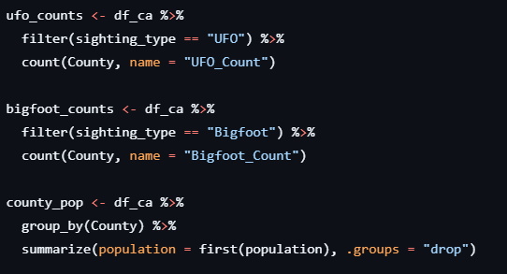
Figure 1. Functional programming example, using our df_ca database to assign new variables to store intermediate tabular data easier to interact with.
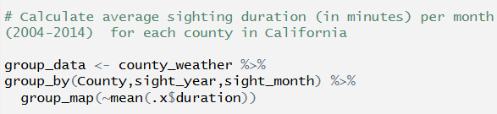
We also used functional programming to calculate average sighting duration and total sighting count for each county, month, and year. This dataset, which was created using functional programming, was then used to train and test our machine learning models.
Figure 2. Functional programming example, grouping our UFO sighting/weather dataset by county to calculate average sighting duration per county, month, and year.
We also used functional programming to pull specific variables and create a new analysis dataset using data obtained from the Robert Wood Johnson Foundation’s County Health Rankings website. We downloaded the full County Health Rankings for California from 2010-2025. The data was stored in multi-sheet excel spreadsheets. We wrote a function to extract only the years of potential life lost rate (YPLL), the state, county, reported deaths and FIPS code for each year and to merge the extracted variables together.
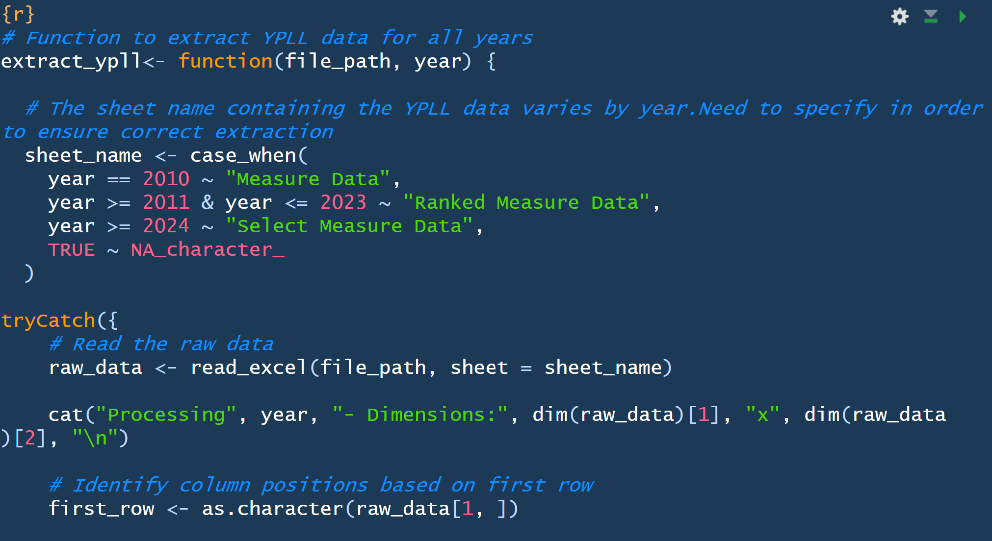
Figure 3. Functional programming example, to extract and standardize years of potential life lost data.
- Machine Learning Paradigm
We used a data-to-model machine learning paradigm to train and test a prediction model for two outcomes per county, month, and year: total sighting count and average sighting duration.
Data collection: We used a functional programming paradigm (described above) to read in and wrangle the data, summarizing monthly average sighting duration and total sighting count for each county in California from January 2004-December 2014, along with the average temperature and average precipitation.
Feature engineering: We encoded a categorical variable for season, in order to assess whether the outcomes of interest are more impacted by linear time or by season.
Model training and evaluation: After removing missing data and outliers, we 80/20 split our data into a training data set and a test data set. We then trained two random forest models for each outcome of interest: average sighting duration and total number of sightings per county per month from January 2004 to December 2014. Each of the two random forest models incorporated a different time metric (month/year or season).
Model 1: Average sighting duration = year + month + county + average temperature + average precipitation + total number of sightings
Model 2: Average sighting duration = season + county + average temperature + average precipitation + total number of sightings
Model 3: Total number of sightings = year + month + county + average temperature + average precipitation
Model 4: Total number of sightings = season + county + average temperature + average precipitation
We only included total sighting count as a predictor for average sighting duration (not vice versa) to account for the fact that very high outliers in the average sighting duration data might be the result of low counts that are also highly inaccurate. Most of the outliers for the average sighting duration data were based on one sighting.
Model deployment: After training the models, we then tested them. The accuracy metrics are listed in the table below. We ran one linear regression model for each outcome (using season as the time metric since those models were slightly more accurate than the ones that used month and year as the time metric) just to see if there would be a notable difference.
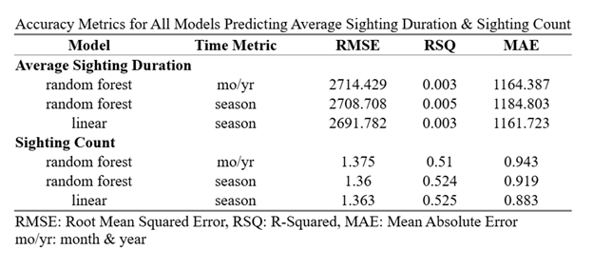

Table 1. Accuracy metrics for all machine learning models predicting average sighting duration and sighting count

For each outcome, all three models were similar in terms of accuracy, which tells us that linear regression is probably the way to go; random forest probably would likely lead to overfitting. All three models were not very accurate for the average sighting duration outcome, accounting for only ~0.3-0.5% of the variation in the outcome.
The model was more accurate for the sighting count outcome, accounting for ~50% of the variation in the outcome. The random forest model that incorporated season had more predictive accuracy for sighting count than the model that used the month and year time metric. The RMSE tells us that the linear model's predictions of total monthly sightings are, on average, about 1.36 counts off from the truth.
Dashboard Creation and Analysis
This dashboard was developed using Quarto within Rstudio to create a static dashboard for data visualization. It was structured as a Quarto website with a _quarto.yml file to define the global settings (site title, navigation bar, theme, and custom styling). The layout and content were organized within the index.qmd, this file uses Quarto’s grid and card system to arrange text and visualizations.
Data visualizations were created using R-based plotting libraries (table 1); files for generating the data visualizations are included in our GitHub repository and the graphs are displayed in the dashboard. This set up allowed analytical outputs and narrative text to coexist in the same display Headers and internal dependencies were used to define logical sections and control layout behavior across the dashboard.
Version control and collaboration were managed through a shared GitHub repository which enabled iterative development, tracked changes, and easy group collaboration. Once the dashboard was complete, it was rendered locally on the command line (quarto render) to create a static HTML output. The finalized site was deployed to GitHub Pages with Quarto’s built-in publishing workflow. Quarto’s publishing workflow automatically generates a gh-pages branch which contains the rendered site files. The dashboard is now publicly available via a GitHub Pages URL (link to dashbaord).
This approach allowed us to integrate reproducible analysis, modern dashboard design, and web deployment.
Table 2. Summary of R packages used in dashboard creation.
R package | Purpose in Project
readr | Import Excel files into R
readxl | Import Excel files into R
dplyr | Data manipulation: filtering, grouping, summarizing, joining datasets
tibble | Create and manage data frame objects, compatible with tidyverse
tidyverse | Cohesive framework for data import, wrangling, visualization, and functional programming
tidymodels | Build, train, and evaluate machine learning models within tidy workflow
tigris | Retrieve U.S Census geographic boundary files for spatial analysis
ranger | Fit random forest models for productive modeling and classification tasks
ggplot2 | Create static visualizations
ggridges | Create ridge density plots for visualizing distributions across categories
leaflet | Used to create interactive maps for spatial data visualization
Leaflet.extras | Extend leaflet maps with additional interactive features
Grid | Low level control of graphical layouts and plot arrangement
lubridate | Parsing, transforming, analyzing date-time variables
tm | Text mining tasks (corpus creation, cleaning, term processing)
stringr | String manipulation (pattern matching and text cleaning)
png | Read and display PNG image files
sf | Handle and manipulate spatial vector data using simple features
lubridate | Parsing, transforming, and analyzing date-time variables
purrr | Functional programming, iteration over lists and data structures
htmlTable | Generate formatted HTML tables
tableHTML | Create interactive HTML tables with styling and sorting options
webshot | Capture screenshots of HTML tables or widgets for export and documentation

Major Findings
By analyzing the UFO data alone, we notice several interesting findings. For this written submission, this list will be non-exhaustive but will convey the most notable points.
Firstly, we see that ‘light’ is the most popular form of observed UFO, followed by circle, triangle, fireball, and sphere. This observation is interesting because all forms are non-descript, and a far from the standard flying saucer model pervasive in pop culture.
We also see that the vast majority of UFO sightings occur at night. Although this may seem contrary to the findings of Medina et al (2023), the fact that light is the most observed UFO shape may make these two findings non-contradictory.
Interestingly, the UFO shapes with the longest sighting durations are ‘egg’, followed by ‘cigar’ and ‘cone’, with ‘chevron’ in last place. While the first three shapes are non-descript, the latter shape is not. This may be explained by many US military planes being described as chevron shaped.
In terms of correlative data between UFO sightings and weather, bigfoot sightings, we see no correlation between county UFO sightings and precipitation, in line with the observations of Medina et al. We do see, however, a degree of correlation between UFO and Bigfoot sightings across Californian counties when taking county populations into account. While non-log transformed data sees a high R^2 value of 0.88, this could be due to its two notable outliers. Log transforming these plots shows greater relative clarity, with an R^2 value of 0.64 (Figure 2). This observation is notable because UFO sightings and Bigfoot sightings are two independent, distinct supernatural phenomena, whose ideal sighting conditions should not overlap with one another. This finding could lend credence to the statement of Worsham et al that UFO sightings are more likely to be reported by those with prior held beliefs of supernatural beings.
We also noted distinct regional variations in types of sightings. Los Angeles County had by far the highest number of UFO sightings, with more than 800 reports between 2004 and 2014. There appears to be a consistent association across our study period with dryer, warmer areas of the state (the Southern part of the state) with higher numbers of UFO sightings. Dryer, warmer nights often mean clearer nights, and increased visibility compared to cooler foggier parts of the state where visibility might be limited. The combination of increased visibility alongside the location of both private and government launch and testing sites (e.g. SpaceX, Northrup-Grumman, and Vandenberg Airforce Base, among others) could help explain why the majority of UFO sightings are clustered in the Southern part of the state.
Given that the next county with the second largest number of sightings (San Diego) had nearly half the number of reported sightings, it's possible that the out sized number of UFO sightings in LA County might be due to the location of SpaceX. SpaceX was headquartered in Hawthorne, California between 2002 and 2024, which is located in Southwestern LA County (Kite, A., 2025). In 2024, SpaceX moved its headquarters to be located outside of Brownsville, TX (Kite, A., 2025). SpaceX began testing the Falcon 1 rocket in March of 2006, before successful launch of the Falcon 1 in September of 2008. It's possible that the increased number of UFO sightings in LA County could be at least partially associated with repeated tests and launches from SpaceX, which overlap with our study period (2004-2010). The number of reported sightings begins to be more heavily concentrated in the Southern portion of the state from 2007 onward, which is consistent with when SpaceX began their Falcon 1 tests (Vaziri, A., 2025; Berboucha, M., 2017).
Similarly, there appeared to be regional clustering of the reports of Bigfoot sightings. Given the known habit of Bigfoot, temperate forests, it makes sense that the vast majority of Bigfoot sightings are concentrated in the Northern, forested parts of the state. Particularly in State and National parks like the Redwoods, and Yosemite.
There does not appear to be a substantiated association with the locations of either UFO or Bigfoot sightings and years of potential life lost rates in California counties between 2004 and 2014. Rather counties with high YPLL rates appeared to be counties that were more likely to be rural, suggesting that the patterning of YPLL assessments is likely to be associated with other social determinants of health. Future studies ought to examine how social determinants of health, particularly factors relating to disinvestment in rural areas, are likely to impact access to care. Additionally, the funneling of resources and economic opportunities toward urban hubs like San Francisco, Los Angeles, Sacramento, and San Diego may be creating unintentional consequences for rural counties surrounding them which have historically employed lots of migrant workers on farms who are likely to be marginalized and vulnerable.
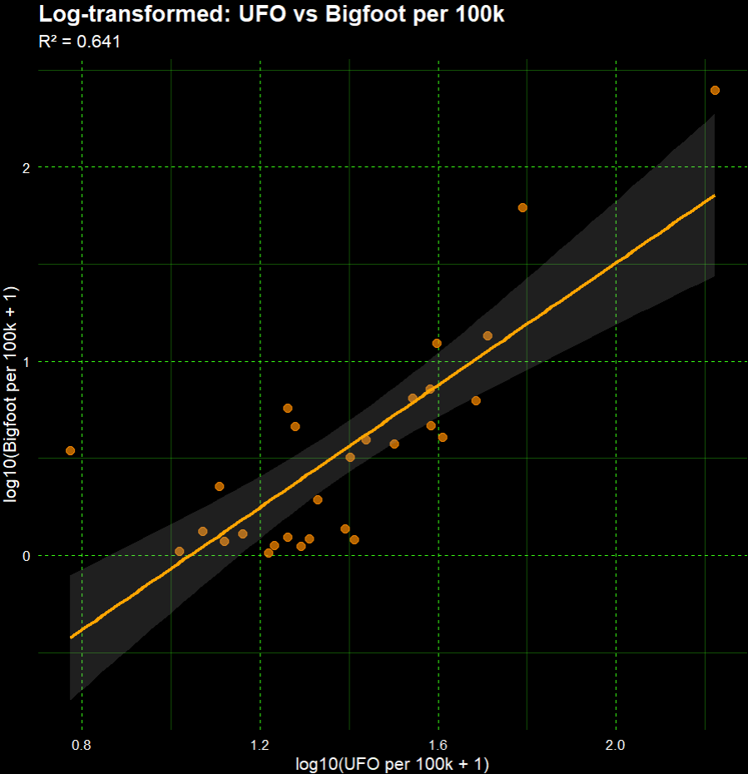
Figure 5. Log transformed scatter plot data showing per capita bigfoot sightings mapped against UFO sightings per Californian county.
Challenges and What We Learned
We initially encountered some issues with the NUFORC data – we wanted to use more recent data, but (as described in the Attempted NUFORC Scraping section above) it was very difficult to pull UFO sighting data past 2014. Once we read in the 2004-2014 NUFORC data, we needed to connect it to weather and health data in order to run our machine learning models and compare sighting data to health metrics. There were two challenges related to linking all three datasets.
Weather Data Challenges
County-level time series data is not available through the NOAA’s API Web Service. It is available through the NOAA’s Climate at a Glance National Time Series Data Service API. We tried pulling data from this API using a GET command, but this approach did not work. Instead, we created a data frame of URLs that incorporated every path parameter combination we needed to pull in average monthly weather data for every county in California from January 2004-December 2014. We used the path parameters specified by the Climate at a Glance National Time Series Data Service API:
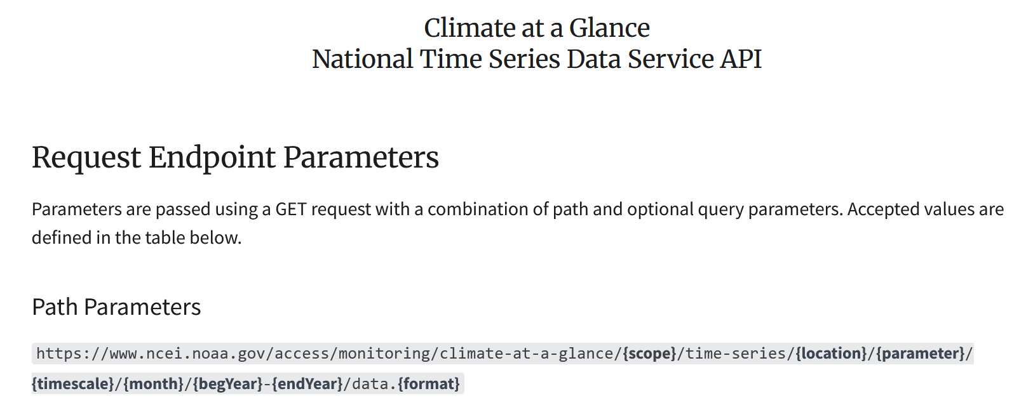
Screenshot 1. Path parameters of the Climate at a Glance National Time Series Data Service API. (NCEI)
Then, we used a forloop to read data in each county’s time series as a CSV using the URL data frame and append them all into one data frame. Another problem then arose – the weather and health data were at a county level, but the UFO sighting data only provided the city of each sighting.
Attempted NUFORC Scraping
We attempted to use functional programming to also scrape updated data from the National UFO Reporting Center (NUFORC)’s website, since the data we had obtained from CORGIS spanned from 2004-2014, but we were ultimately unable to successfully scrape more than 100 entries from the website due to its structure.
We first built a function to analyze the structure of the NUFORC page, and to identify the table in which the data was being stored.
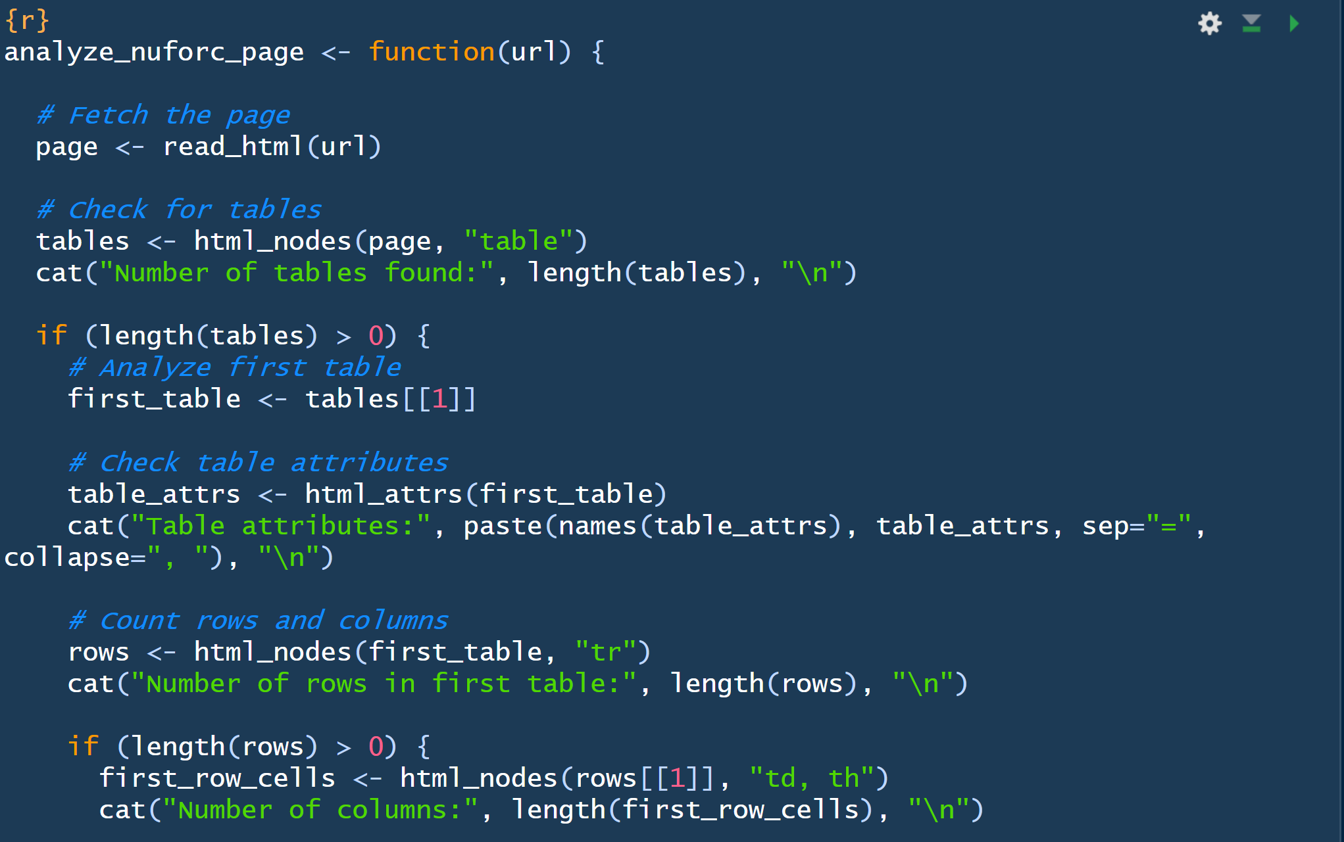
Figure 4. Example of functional programming used to analyze the structure of a webpage for scraping purposes.
After using our function to explore the page structure of the NUFORC site, we were able to use the ‘rvest’ package to extract the first 100 entries that were stored in the table from 1995. We struggled to extract more than the original 100 entries stored in the direct html script. Upon manual exploration, the data seemed to be stored inside a wordpress table, but the contents of it were hidden, and the page used JavaScript loading, making it difficult to extract all the data. After repeated attempts to extract the data from the NUFORC site, we determined it would be best to proceed with the data we had access to from CORGIS even though the timeframe we were able to assess was more limited.
Merging UFO Sighting, Weather, and Health Data
It was challenging to find a national dataset linking cities and counties. We ended up using FIPS (Federal Information Processing Standards) codes, “a set of numeric designations given to state, cities and counties by the U.S. federal government” (State, County and City FIPS Reference Table, 2025). We then used a join command to join the datasets based on county.
Overall, we were able to creatively use the programming paradigms taught in this class to:
- Pull, clean, and link data from disparate data sources.
- Visualize trends in the linked data.
- Create and assess the accuracy of a prediction model based on the linked data.
- Display our findings in a deployed dashboard.
References
Berboucha, M. (2017, December 24). SpaceX’s Falcon 9 Launch Causes #Aliens To Trend. Retrieved December 18, 2025, from https://www.forbes.com/sites/meriameberboucha/2017/12/24/spacexs-falcon-9-has-successfully-lifted-off/
County Time Series | Climate at a Glance | National Centers for Environmental Information (NCEI). www.ncei.noaa.gov. https://www.ncei.noaa.gov/access/monitoring/climate-at-a-glance/county/time-series
GreatImposter. (2017). Bfro Bigfoot sighting report. Retrieved from https://www.kaggle.com/datasets/chemcnabb/bfro-bigfoot-sighting-report
Kite, A. (2025, February 13). SpaceX’s Starbase one step closer to becoming official Texas town [Text.Article]. FOX 7 Austin; FOX 7 Austin. https://www.fox7austin.com/news/starbase-texas-election-spacex
Medina, R. M., Brewer, S. C., & Kirkpatrick, S. M. (2023). An environmental analysis of public UAP sightings and sky view potential. Scientific Reports, 13(1). doi:10.1038/s41598-023-49527-x
Menezes, D. (2025, May 1. Nearly half of US voters believe government hiding UFO evidence: Survey [Text]. The Hill. https://thehill.com/policy/defense/5276225-americans-ufo-evidence-survey-decision-desk-hq-newsnation/
The National UFO Reporting Center Online Database. (2021, September 6. The National UFO Reporting Center. https://nuforc.org/databank/
Saad, L. (2021, August 20. Larger Minority in U.S. Says Some UFOs Are Alien Spacecraft. Gallup. https://news.gallup.com/poll/353420/larger-minority-says-ufos-alien-spacecraft.aspx
State, County and City FIPS Reference Table. (2025). Retrieved from https://data.transportation.gov/Railroads/State-County-and-City-FIPS-Reference-Table/eek5-pv8d/about_data
UFO sightings CSV file. (n.d.). Retrieved from https://corgis-edu.github.io/corgis/csv/ufo_sightings/
US Department of Commerce N. API Web Service. www.weather.gov. https://www.weather.gov/documentation/services-web-api
Vaziri, A. (2025, January 24). SpaceX launch lights up Bay Area skies—And sparks UFO speculation. San Francisco Chronicle. https://www.sfchronicle.com/bayarea/article/spacex-falcon-9-starlink-launch-20053824.php
Worsham, C. M., Zimerman, A., Woo, J., Shaw, D., & Jena, A. B. (2023). Association between UFO sightings and emergency department visits. The American Journal of Emergency Medicine, 66, 164–166. doi:10.1016/j.ajem.2023.01.022

